American Legion Post 23
  - BINGO Fundraiser — Prize Sheet
Date: | 06/06/2026 | Start Time: | 6:00 PM
Location: | 1322 E Depot St., Shelbyville
Doors Open: | 5:15 PM | Admission / Pack Price: | Regular BINGO cards: $5  Early Bird specials: $5  Special games (2,4,6,8): $2 ea.  Yellow Special Jackpot: $5 each
Prizes by Game
Game # | Card / Pattern | Winner(s) | Prize
1 | Blue Card — Regular Bingo | Single / Split | $30
2 | Purple Special — T | Single / Split | $60 | 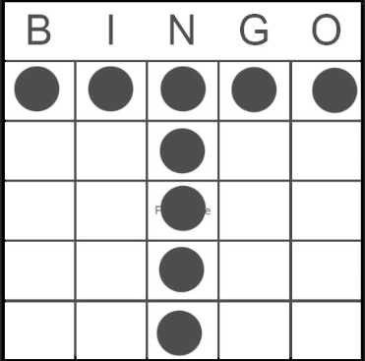
3 | Orange Card — Regular Bingo | Single / Split | $30
4 | Red Special — V | Single / Split | $60 | 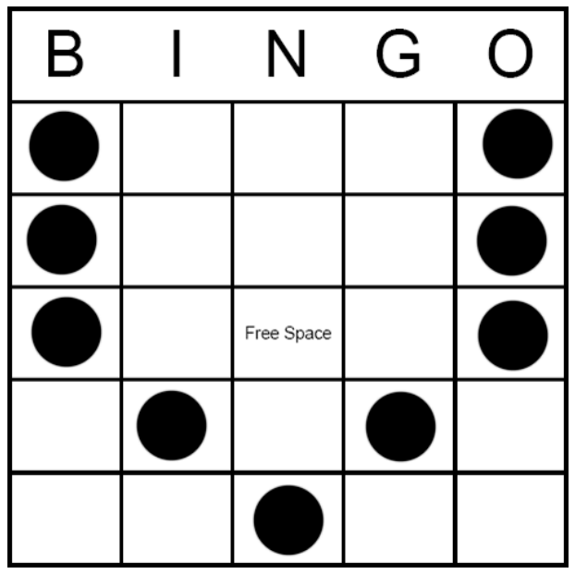
5 | Green Card — Regular Bingo | Single / Split | $30
 | 15-minute intermission
6 | Green Special — M | Single / Split | $60 | 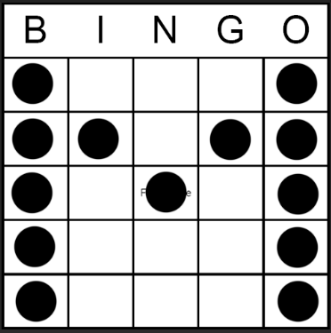
7 | Pink Card — Regular Bingo | Single / Split | $30
8 | Blue Special — X | Single / Split | $60 | 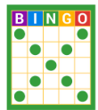
9 | Blue Card — Regular Bingo | Single / Split | $30
10 | Yellow Special — Coverall (Jackpot) | Single / Split | $400 | 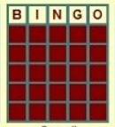
Specials / Jackpots
Item | Details
50/50 Raffle | Drawing time: After Game 7
Notes
- All prizes and game count are subject to change.
- In the event of multiple winners, prize may be split unless otherwise announced.
- To claim a prize, winner(s) must be present and verify winning card(s).
- House rules apply; caller’s decision is final.
Proceeds benefit American Legion Post 23 programs and community support.

